Grove - Serial RF Pro

(Redirected from [Twig - Serial RF Pro v0.9b](http://www.seeedstudio.com/wiki/index.php?title=Twig_-_Serial_RF_Pro_v0.9b&redirect=no))

|  |
| --- |
| **Contents**   [[hide](javascript:toggleToc())]   * [1 Introduction](http://www.seeedstudio.com/wiki/index.php?title=Twig_-_Serial_RF_Pro_v0.9b#Introduction) * [2 Features](http://www.seeedstudio.com/wiki/index.php?title=Twig_-_Serial_RF_Pro_v0.9b#Features) * [3 Application Ideas](http://www.seeedstudio.com/wiki/index.php?title=Twig_-_Serial_RF_Pro_v0.9b#Application_Ideas) * [4 Cautions](http://www.seeedstudio.com/wiki/index.php?title=Twig_-_Serial_RF_Pro_v0.9b#Cautions) * [5 Specification](http://www.seeedstudio.com/wiki/index.php?title=Twig_-_Serial_RF_Pro_v0.9b#Specification)   + [5.1 Key Specification](http://www.seeedstudio.com/wiki/index.php?title=Twig_-_Serial_RF_Pro_v0.9b#Key_Specification) * [6 Pin definition and Rating](http://www.seeedstudio.com/wiki/index.php?title=Twig_-_Serial_RF_Pro_v0.9b#Pin_definition_and_Rating) * [7 Mechanic Dimensions](http://www.seeedstudio.com/wiki/index.php?title=Twig_-_Serial_RF_Pro_v0.9b#Mechanic_Dimensions) * [8 Usage](http://www.seeedstudio.com/wiki/index.php?title=Twig_-_Serial_RF_Pro_v0.9b#Usage)   + [8.1 Hardware Installation](http://www.seeedstudio.com/wiki/index.php?title=Twig_-_Serial_RF_Pro_v0.9b#Hardware_Installation)   + [8.2 Commands and Responses Summary](http://www.seeedstudio.com/wiki/index.php?title=Twig_-_Serial_RF_Pro_v0.9b#Commands_and_Responses_Summary)   + [8.3 Programming](http://www.seeedstudio.com/wiki/index.php?title=Twig_-_Serial_RF_Pro_v0.9b#Programming)   + [8.4 Example](http://www.seeedstudio.com/wiki/index.php?title=Twig_-_Serial_RF_Pro_v0.9b#Example) * [9 Bill of Materials (BOM) /parts list](http://www.seeedstudio.com/wiki/index.php?title=Twig_-_Serial_RF_Pro_v0.9b#Bill_of_Materials_.28BOM.29_.2Fparts_list) * [10 FAQ](http://www.seeedstudio.com/wiki/index.php?title=Twig_-_Serial_RF_Pro_v0.9b#FAQ) * [11 Support](http://www.seeedstudio.com/wiki/index.php?title=Twig_-_Serial_RF_Pro_v0.9b#Support) * [12 Version Tracker](http://www.seeedstudio.com/wiki/index.php?title=Twig_-_Serial_RF_Pro_v0.9b#Version_Tracker) * [13 Bug Tracker](http://www.seeedstudio.com/wiki/index.php?title=Twig_-_Serial_RF_Pro_v0.9b#Bug_Tracker) * [14 Additional Idea](http://www.seeedstudio.com/wiki/index.php?title=Twig_-_Serial_RF_Pro_v0.9b#Additional_Idea) * [15 Resources](http://www.seeedstudio.com/wiki/index.php?title=Twig_-_Serial_RF_Pro_v0.9b#Resources) * [16 How to buy](http://www.seeedstudio.com/wiki/index.php?title=Twig_-_Serial_RF_Pro_v0.9b#How_to_buy) * [17 See Also](http://www.seeedstudio.com/wiki/index.php?title=Twig_-_Serial_RF_Pro_v0.9b#See_Also) * [18 Licensing](http://www.seeedstudio.com/wiki/index.php?title=Twig_-_Serial_RF_Pro_v0.9b#Licensing) * [19 External Links](http://www.seeedstudio.com/wiki/index.php?title=Twig_-_Serial_RF_Pro_v0.9b#External_Links) |

Introduction

Serial RF Pro Grove is a low cost, high performance transparent FSK transceiver with operating at 433/470/868/915 MHz, and the best performance is at 433M(Default). It features small size, high output power, high sensitivity, long transmission distance and high communication data rate with auto set up for communication change and data receiving and transmission control. There is UART interface, it is easy to realize the wireless data transmission with only providing the UART data. It is flexible for the users to set the UART baud rate, frequency, output power, data rate, frequency deviation, receiving bandwidth etc parameters. It is your ideal choice for designing wireless data transmission products which can be widely used on wireless data transmission field.

**Model:**[**WLS31625P**](http://www.seeedstudio.com/depot/grove-serial-rf-pro-p-794.html?cPath=139_140)

[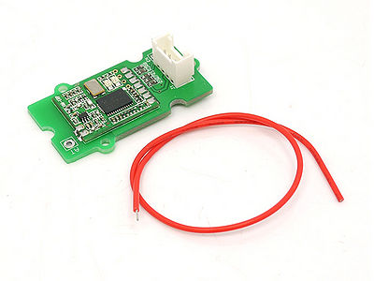](http://www.seeedstudio.com/wiki/File:Twigrf.jpg)

Features

* Grove compatible
* Low cost, high performance, high reliability
* FSK modulation, 2-way half –duplex communication, strong anti-interference
* 433/470/868/915MHz ISM band, globally license free
* Maximal output power 100mW(20dBm), output power adjustable between 1-20dBm
* Sensitivity -117dBm
* Supply current for Tx 100mA@20dBm, 40mA@14dBm
* Supply current for Rx 25mA
* Low current sleep mode 1uA
* Operation frequency can be configured, acceptable for several modules working in different frequency with no disturbance on each other
* Optional for frequency deviation and receiving ISM bandwidth, users can be modulated by software
* Communication speed 1.2kbps -115.2kbps, can be modulated through software
* Longer transmission distance，over 1Km in open air
* RSSI function
* Compliant with FCC, ETSI standards

Application Ideas

* Remote control, remote measurement system
* Wireless meter
* Access control
* Identification system
* Data collection
* IT household appliance
* Intelligence household appliance
* Baby monitoring system

Cautions

**Do remember the UART transfer speed(default is 9600, better not change) if you make some change, or you won't be able to control the module.**

Specification

May include key specification and other specifications.

**Key Specification**

* Operate voltage: +5V
* Communication Protocol: UART
* Storage temperature: -40℃ ~ +150℃
* Operate temperature: -40℃ ~ +85℃
* UART data bit 8 bit
* UART stop bit 1 bit

Pin definition and Rating

|  |  |
| --- | --- |
| **Pad Type (5V Logic level)** | **Description** |
| G(GND) | Ground port |
| EN(ENABLE) | Set low for normal mode as data transceiver (Default is low with 10k to GND). Set high to put into sleep mode. |
| CON(CONFIG) | Set low for configuration mode (connect to GND). Set high for communication (Default is high). |
| RX | UART Data input |
| TX | UART Data output |
| V(VCC) | Designed for 5V(+)supply |
| AT | Antenna pin |

Mechanic Dimensions

[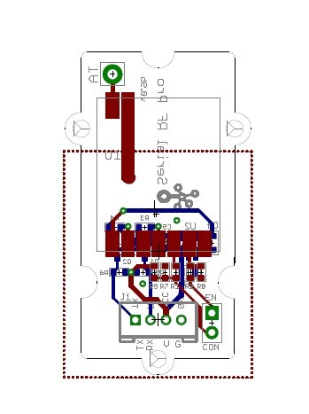](http://www.seeedstudio.com/wiki/File:Rfmodule.jpg)

Dimension:4cm X 2cm

Usage

**Hardware Installation**

**If you want to configure Serial RF Pro Grove, you need to connect the CON pin to ground.**

LED function:

* The red and green LED will flash when there is power and the module is working.
* The module will be ready for configuration mode if EN(ENABLE) pin is low(default is low)，CON(Config) pin is low. When in configuration mode, the red and green LED will both be solidly lit. The green and red LED will not be solidly lit if the module is not in configuration mode.
* The red LED flash when the module is transmitting, the red LED will be off when the transmission is finished.
* The green LED is off when the module is waiting for data to be received, the green LED will flash once when the module receives data.

While the module is in configuration mode, you can modify and query the config of the module. The Config instruction format is as AA+FA+[instruction]+[parameter]. The instruction is 1 byte, the parameter is the HEX data of 0-4 bytes (in big-endian ordering, with the high byte before the low byte). The settings are persisted in non-volatile storage on the device, so the device does not be reconfigured when power is lost.

The instruction’s transfer speed should keeps the same as the transfer speed of UART. The instruction’s transfer speed will change accordingly if changes the transfer speed of UART. The range of transfer speed of the instruction is from 1.2Kbps – 115.2K bps.

**Commands and Responses Summary**

The following table lists the commands and responses involved in interacting with Serial RF Pro v0.9b.

|  |  |  |  |
| --- | --- | --- | --- |
| **Instruction(HEX)** | **Description** | **Config instruction(HEX)** | **Return Value** |
| F0 | Reset to default parameters (except UART transfer speed), no parameter follows | AA FA F0 | 4F 4B 0D 0A （OK /r/n) |
| E1 | Reading the current Config parameter, no parameter follows | AA FA E1 | 16 bytes: (**following the order below**)  working frequency-4 bytes,  wireless data rate-4 bytes,  receiving bandwidth-2 bytes,  frequency deviation-1 byte,  transmission power-1 byte,  UART transfer speed-4 bytes |
| D2 | Set up working frequency，[parameter]4 byte，[parameter] Unit :Hz.  Set up range:   * HM-TRP-433: 414000000-454000000Hz; * HM-TRP-470: 450000000-490000000Hz; * HM-TRP-868: 849000000-889000000Hz; * HM-TRP-915: 895000000-935000000Hz | Example:   * Config instruction: AA FA D2 **36 89 CA C0**, set up frequency as 915000000Hz.(**0x36 89 CA C0=915000000**) * Config instruction: AA FA D2 **19 DE 50 80**, set up frequency as 434000000Hz.(**0x19 DE 50 80=434000000**) | 4F 4B 0D 0A （OK /r/n) |
| C3 | Set up wireless data rate，[parameter]4 byte，[parameter] unit :bps.  Set up range:1200-115200 bps | Example:   * Config instruction: AA FA C3 **00 00 25 80**,set up transfer speed as 9600bps.(**0x00 00 25 80=9600**) * Config instruction: AA FA C3 **00 00 96 00**, set up transfer speed as 38400bps.(**0x00 00 96 00=38400**) | 4F 4B 0D 0A （OK /r/n) |
| B4 | Set up receiving bandwidth，[parameter]2 byte，[parameter]Unit :KHz  Set up range:30-620KHz | Example:   * Config instruction: AA FA B4 **00 69**, set up receiving band as 105KHz.(**0x00 69=105**) * Config instruction: AA FA B4 **01 2C**, set up receiving band as 300KHz.(**0x01 2C=300**) | 4F 4B 0D 0A （OK /r/n) |
| A5 | Set up frequency deviation，[parameter]1 byte，[parameter]Unit :KHz  Set up range:10-160KHz | Example:   * Config instruction: AA FA A5 **23**, set up modulation frequency as 35KHz.(**0x23=35**) * Config instruction: AA FA A5 **32**, set up modulation frequency as 50KHz.(**0x32=50**) | 4F 4B 0D 0A （OK /r/n) |
| 96 | Set up transmission power ,[parameter]1 byte，0~7level  Set up range:0-7level(1-20 dBm) | Example:   * Config instruction: AA FA 96 **07**, set up transmission power as level 7 (+20 dBm) * Config instruction:AA FA 96 **03**, set up transmission power as level 3 (+8 dBm)   Transmission power level Transmission power  7 +20dBm  6 +17dBm  5 +14dBm  4 +11dBm  3 +8dBm  2 +5dBm  1 +2dBm  0 +1dBm | 4F 4B 0D 0A （OK /r/n) |
| 1E | Set up UART transfer speed，[parameter]4 byte，[parameter] unit: bps  Set up range:1200-115200 bps | Example:   * Config Instruction :AA FA 1E **00 00 25 80**,set up speed as 9600bps.(**0x00 00 25 80=9600**) * Config instruction :AA FA 1E **00 00 96 00**, set up speed as 38400bps.(**0x00 00 96 00=38400**) | 4F 4B 0D 0A （OK /r/n) |
| 87 | Wireless signal strength when receiving useful data, follows no [parameter] | Config Instruction：AA FA 87  [WirelesssignalstrengthRSSI.jpg](http://www.seeedstudio.com/wiki/File:WirelesssignalstrengthRSSI.jpg) | RSSI value is 8 bit, range: 0-255 |
| 78 | Disturb wireless signal strength, follows no [parameter]  Note：   * Modulation index : h = Fd/Rb, Range is 0.5 ~ 32. * If h>1, BW =Rb+2Fd; If h<1, BW =2Rb+ Fd. | Config Instruction：AA FA 78 | RSSI value is 8 bit , range: 0-255 |

**Programming**

***You need two RF Pro Grove units and two Seeeduino/Arduinos to do the demo.***

[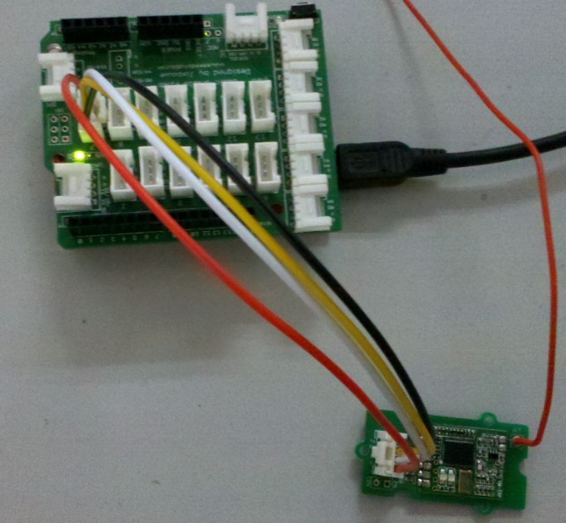](http://www.seeedstudio.com/wiki/File:Rfdemo.jpg)

*Connect CON pin to LOW/GND to enter****configure mode***

Demo code on Seeeduino/Arduino #1:

//send data routine

#include <NewSoftSerial.h>

**NewSoftSerial** mySerial(7, 8);

**void** **setup**()

{

mySerial.begin(9600); // the baud rate

**Serial**.begin(9600); // the baud rate

}

**void** **loop**()

{

**if**(**Serial**.available())

{

mySerial.print((**unsigned** **char**)**Serial**.read());

}

}

Demo code on Seeeduino/Arduino #2:

//receive data routine

#include <NewSoftSerial.h>

**NewSoftSerial** mySerial(7, 8);

**void** **setup**()

{

mySerial.begin(9600); // the baud rate

**Serial**.begin(9600); // the baud rate

}

**void** **loop**()

{

**if**(mySerial.available())

{

**Serial**.print((**unsigned** **char**)mySerial.read());

}

}

**Example**

The projects and application examples.

Bill of Materials (BOM) /parts list

|  |  |  |  |
| --- | --- | --- | --- |
| **Qty** | **Value** | **Device** | **Parts** |
| 6 | 10kΩ | R0603_S | R2, R3, R4, R5, R6, R9 |
| 2 | 10uF | C0805_S | C1, C4 |
| 2 | 15kΩ | R0603_S | R7, R8 |
| 1 | 100nF | C0603_S | C5 |
| 1 | 470Ω | R0603_S | R1 |
| 1 | HEADER_1X2_2.54 | HEADER_1X2_2.54 | CON (not soldered) |
| 1 | HM_TRP_433S | HM_TRPSMD | U1 |
| 1 | MIC5205_3.3 | MIC5205_3.3 | U2 |
| 2 | BSN20 | N_MOS | Q1, Q2 |
| 1 | GROVE_2.0 | GROVE_2.0 | J1 |
| 1 | wire antenna |  | Not soldered, shipped with the product |

FAQ

Please list your question here:

Support

If you have questions or other better design ideas, you can go to our [forum](http://www.seeedstudio.com/forum) or [wish](http://wish.seeedstudio.com/) to discuss.

Version Tracker

|  |  |  |
| --- | --- | --- |
| **Revision** | **Descriptions** | **Release** |
| v0.9b | Initial public release | date |

Bug Tracker

Bug Tracker is the place you can publish any bugs you think you might have found during use. Please write down what you have to say, your answers will help us improve our products.

Additional Idea

The Additional Idea is the place to write your project ideas about this product, or other usages you've found. Or you can write them on Projects page.

Resources

The resources need to be downloaded, like Eagle file, Demo code, project or other datasheet.

* [Data sheet for the HopeRF HM-TRP Series 100mW Transceiver modules V1.0](http://www.hoperf.com/upload/rf_app/hm-trp.pdf)